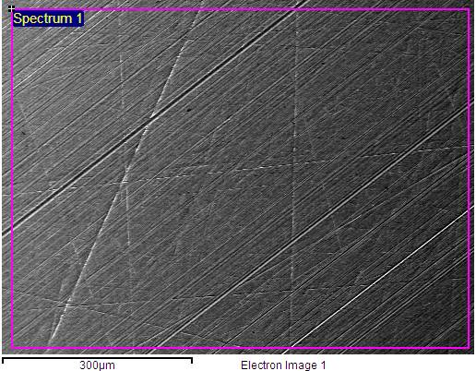

Arp 2000
11.12.2009 9:42:43MST014
Processing option : All elements analysed (Normalised)

Spectrum | In stats. | Si | Cr | Mn | Fe | Mo | Total
Spectrum 1 | Yes | 0.34 | 0.85 | 0.51 | 98.27 | 0.02 | 100.00
Mean |  | 0.34 | 0.85 | 0.51 | 98.27 | 0.02 | 100.00
Std. deviation |  | 0.00 | 0.00 | 0.00 | 0.00 | 0.00
Max. |  | 0.34 | 0.85 | 0.51 | 98.27 | 0.02
Min. |  | 0.34 | 0.85 | 0.51 | 98.27 | 0.02

All results in weight%
Kovuus ≈430HV1
Lujuusluokka 12.9

